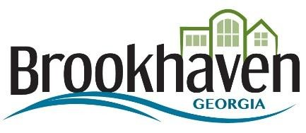

Request for Proposal (RFP)
RFP 19-217
Ashford Dunwoody Road At Windsor PKWY Intersection GDOT PI #P10016056
ADDENDUM #1

On page 4 of the RFP, under Part Two - Proposal Contents under section VI item # 9, we are required to complete the O.C.G.A. 50-36-1(e)(2) Affidavit Verifying Status Public Benefit (SAVE) form. However, the form was not included in the RFP package. Will you be providing this through an addendum? Yes
2. On page 9 of the RFP under Guidelines, there is a section titled 6.0 Certification with a contract underneath. Is this signature required for the forms section of the submittal? Yes
3. Since this project is not in a federally protected bat area, would the City consider removing the pre-qualification for Bat Survey?
Answer: Remove GDOT area class 1.06(h) Bat surveys from Section VI on Page 6 of the RFP.

